Start with a clean test machine or VM snapshot.
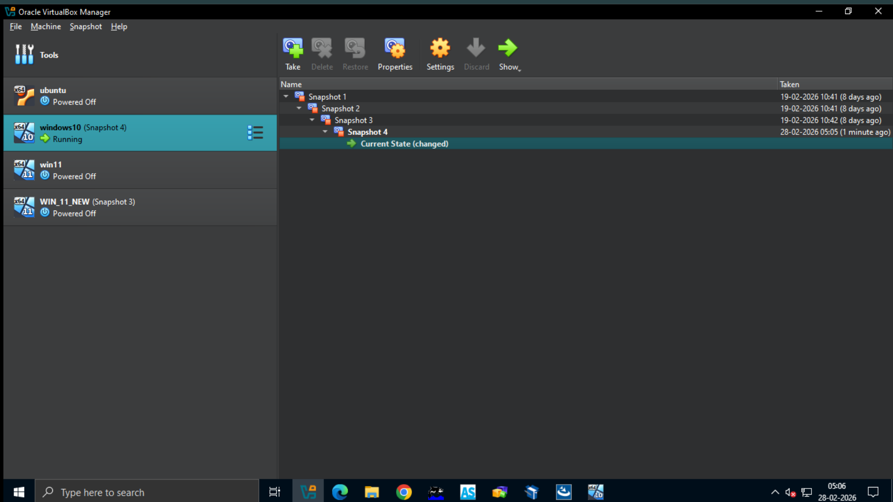

Copy Repackager from Base Machine to Virtual Machine using Network Shared Folder.
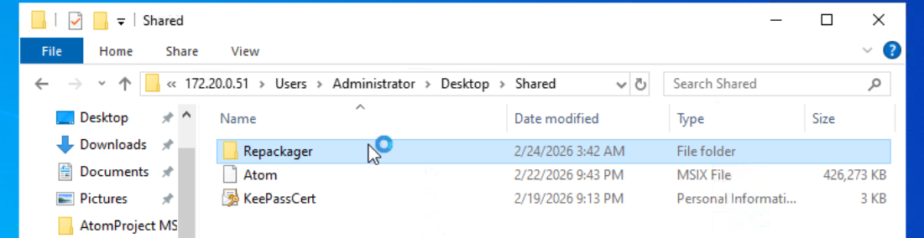

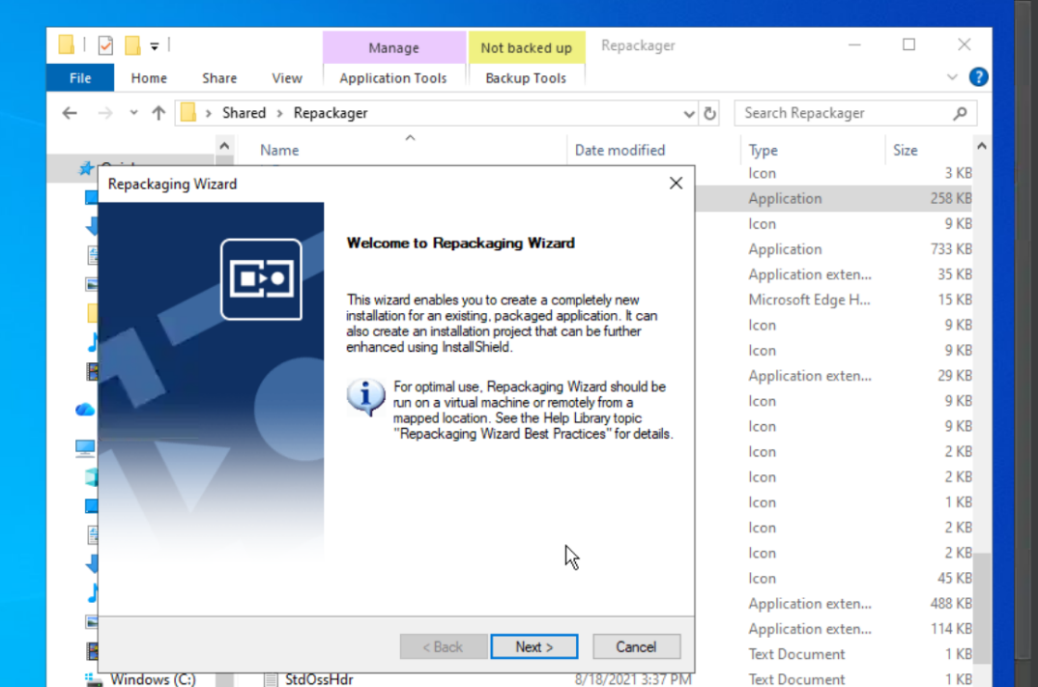
Step 1: go to Shared \Repackager and Double click on Repack to launch the Repackager from it .

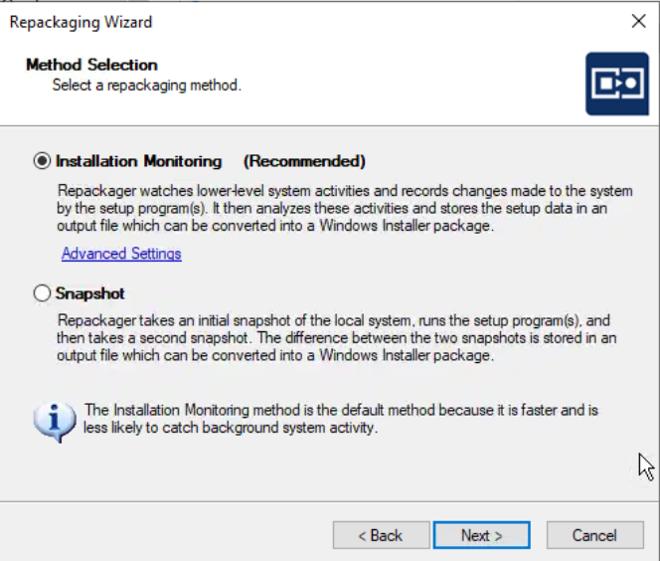
Select Installation Monitoring for capturing
Real time which will records file changes , registry entries , services and shortcut created.
It is more accurate for installers that run normally and don’t block monitoring captures dynamic changes (like services starting, registry writes during installs.)

- Add Notepad++.exe inside VM by downloading .
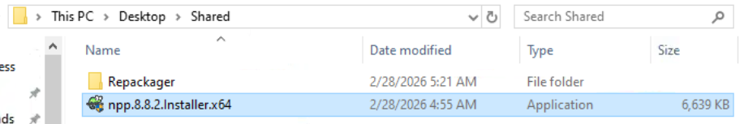

Setup Programs
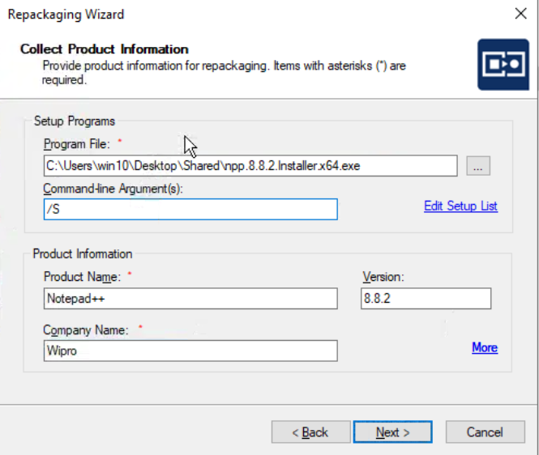
- Program File: Click the [...] button and browse to the location of the Notepad++ installer you downloaded (e.g., npp.8.x.x.Installer.x64.exe).
- Command-line Argument(s): Enter /S (This is the standard silent switch for Notepad++). This ensures the "Installation Monitor" can capture the process without you having to manually click "Next" through the Notepad++ wizard.

Product Information
- Product Name: Notepad++
- Version: 8.8.2 (Enter the specific version number of the installer you are using).
- Company Name: Notepad++ Team (or your own organization name if this is for internal distribution).

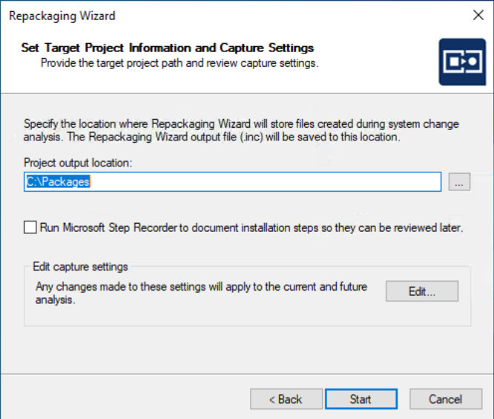
- Project output location: The current path C:\Packages is perfectly fine. This is where the wizard will save the .inc file, which contains all the registry changes and file additions captured during the Notepad++ installation.

- Run Microsoft Step Recorder: Leave this unchecked unless you specifically need a screenshot-by-screenshot documentation of the process for manual review. Since you are using a silent switch (/S), there won't be much for it to record anyway.

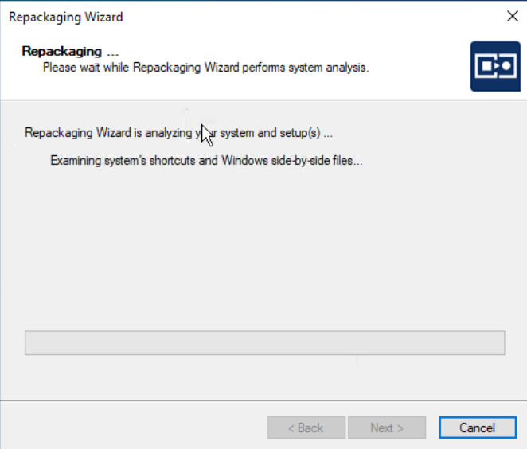
- Edit capture settings: You generally don't need to touch this for a standard app like Notepad++. It is used to "exclude" certain folders or registry keys (like temporary system files) from being captured.

- Once you click Start:
- Initial Snapshot: The tool will take a "Before" snapshot of your system

- Installation: It will automatically run the Notepad++ installer using the /S argument you provided.
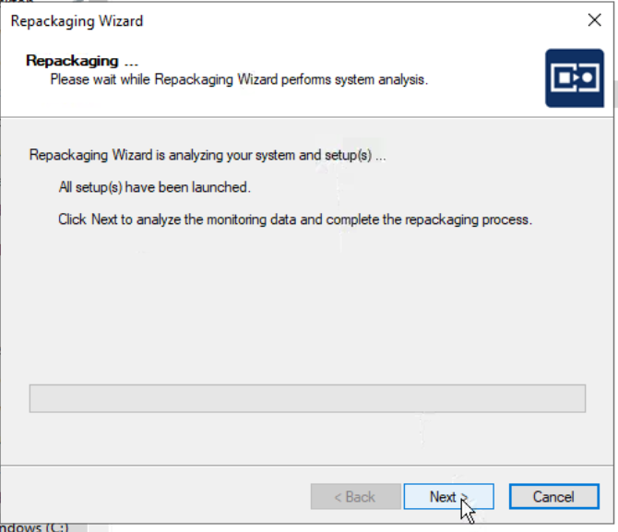

- Final Snapshot: It will take an "After" snapshot to see what changed.

- Generation: It will create the project files in C:\Packages.
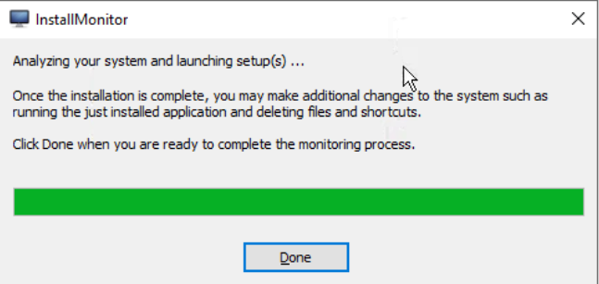
Click Done and Next on above packaging wizard to start Capturing then it will show as below.
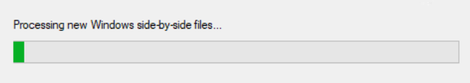

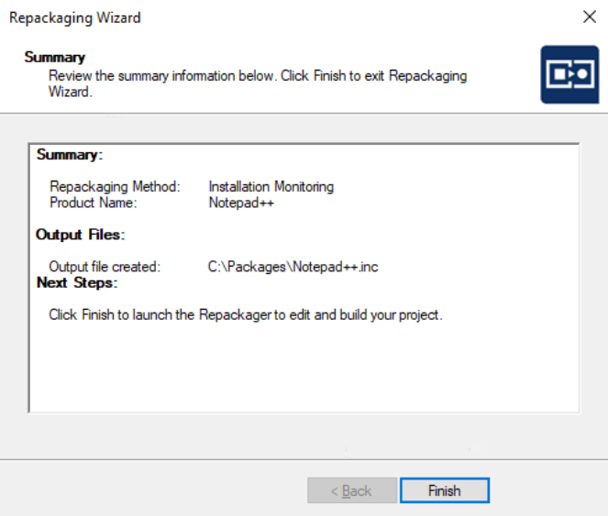
Final Steps to Generate Your MSI
1. Review Captured Data
Before building the MSI, quickly check that the capture is clean:
- Files and Folders: Click this on the left sidebar to see where the files were placed. You should see the Notepad++ folder under %ProgramFiles64Folder%.

- Shortcuts: Verify that a shortcut was created for the desktop or Start Menu so users can actually launch the app.

2. Set Package Information
Click on Package Information under the "Repackaged Output" section in the left sidebar.
Ensure the Product Name, Version, and Manufacturer (Wipro) are exactly how you want them to appear in the "Add or Remove Programs" list on target machines.
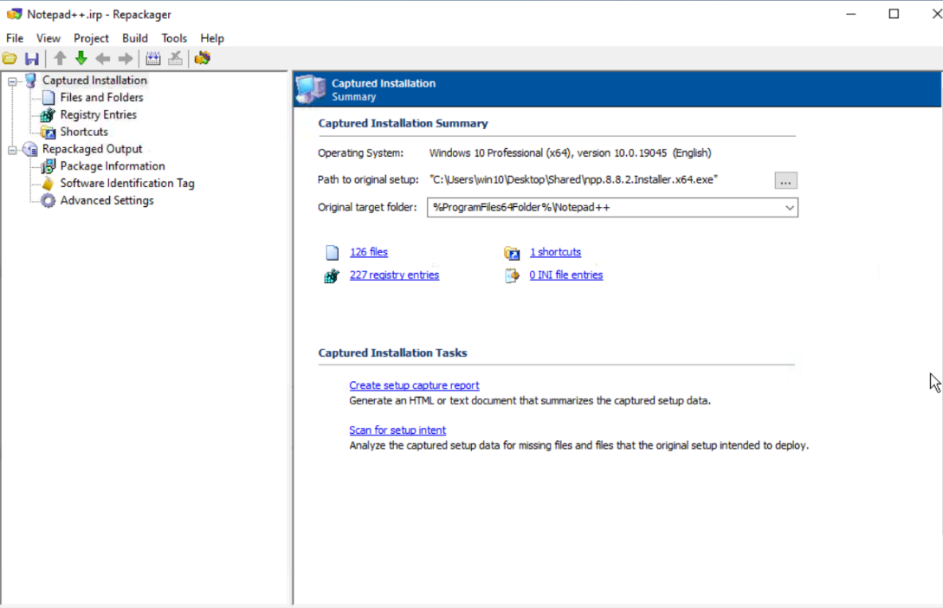

- Click on Build > Build
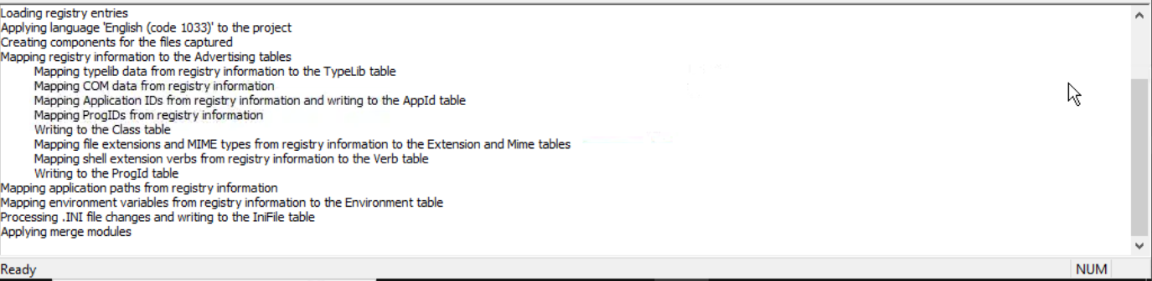
Check Logs for the Completion of the Build

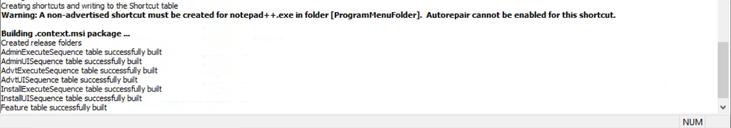

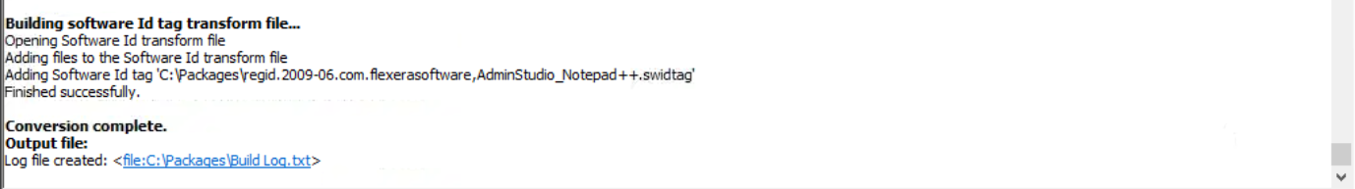

Here the status is Ok and Logs are generated

- Verify the Installation by seeing .msi package inside file This PC/C/Packages/
MSI_Package.
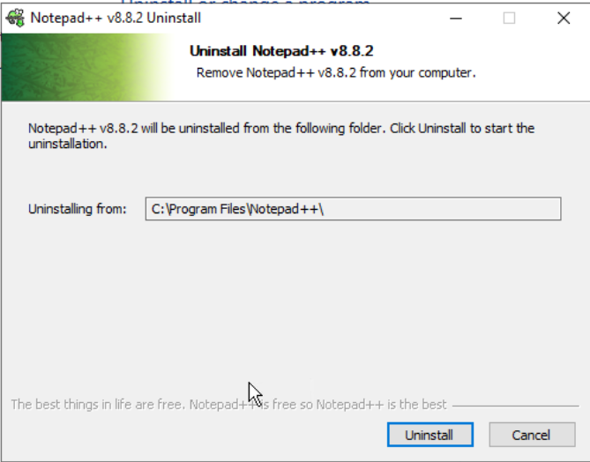
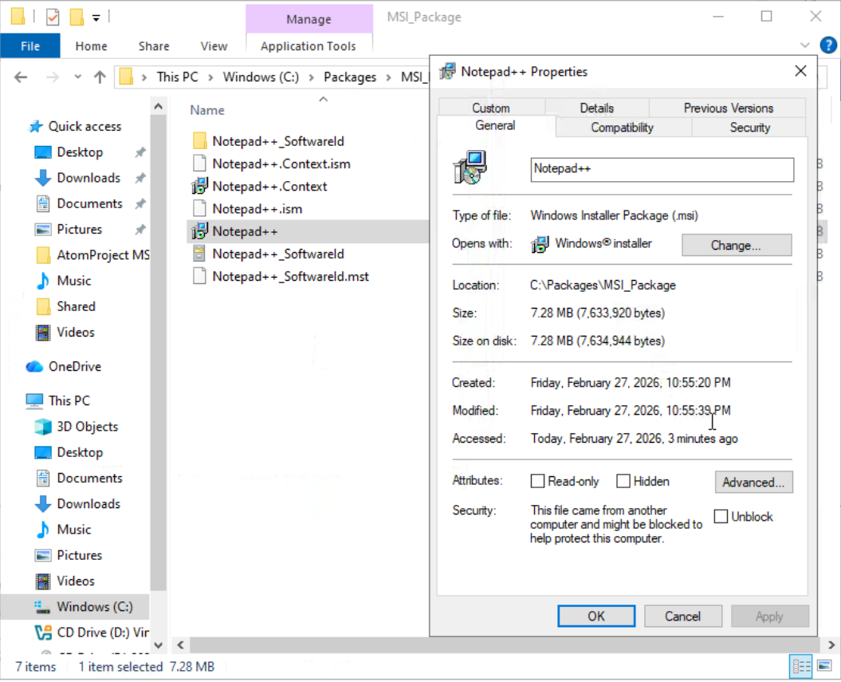
Uninstall the Notepad++ from the

